

**National Immunisation & Vaccination System (NIVS)**

**School Flu User Guide**

Table of Contents

1. Access requirements 3

2. Upload file creation 4

3. Uploading School Flu Vaccination Files 6

4. Editing School Flu Vaccination Records 8

5. School Flu Vaccination details for your Organisation 10

6. Contact Details 11

# Access requirements

Please ensure that your NIVS account is enabled and that you can access the platform. You can do this by logging into NIVS from the sign in page at <https://nivs.ardengemcsu.nhs.uk/> using your OKTA account email address and password.

If you have logged in successfully you will see the NIVS homepage with tiles or options available to select. If your account is disabled you will be presented with a list of your Trust Superusers, that will be able to activate it for you.

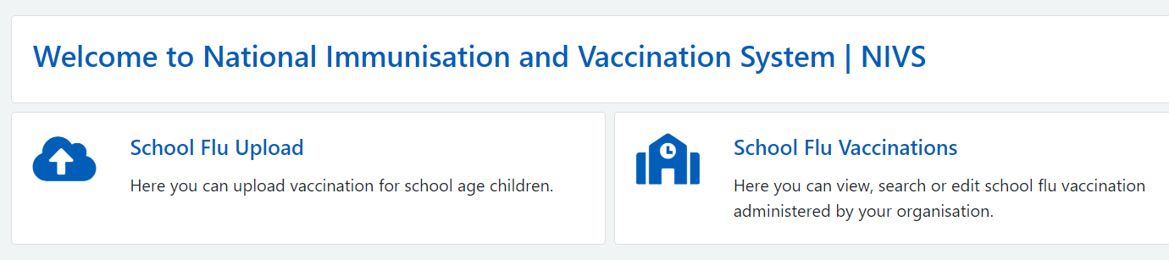

You will require the “School Vaccinator” role to upload school flu vaccinations, you can check that you have this role assigned by clicking your email address at the top right of the NIVS homepage when logged in which will bring up your profile including assigned roles.

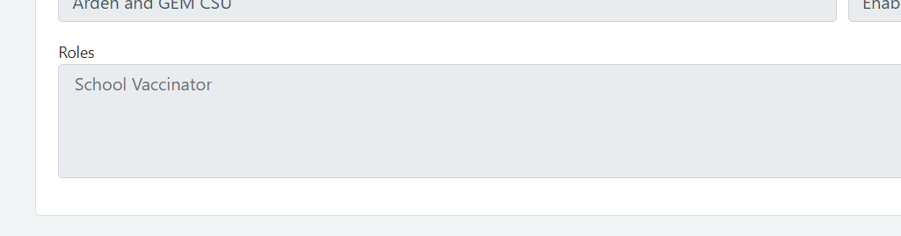

If you do not have the School Vaccinator role please contact your organisation superusers, If you experience any issues or need any further assistance with your account please contact [NIVS@england.nhs.uk](mailto:NIVS@england.nhs.uk)

# Upload file creation

To upload your vaccinations, you will need a completed .CSV template file. Details on how to enter the information can be found on the technical specification document. Both of these documents can be found on our website at [COVID-19 National immunisation and vaccination programme - NHS Arden & GEM CSU (ardengemcsu.nhs.uk)](https://www.ardengemcsu.nhs.uk/services/business-intelligence/nivs/)

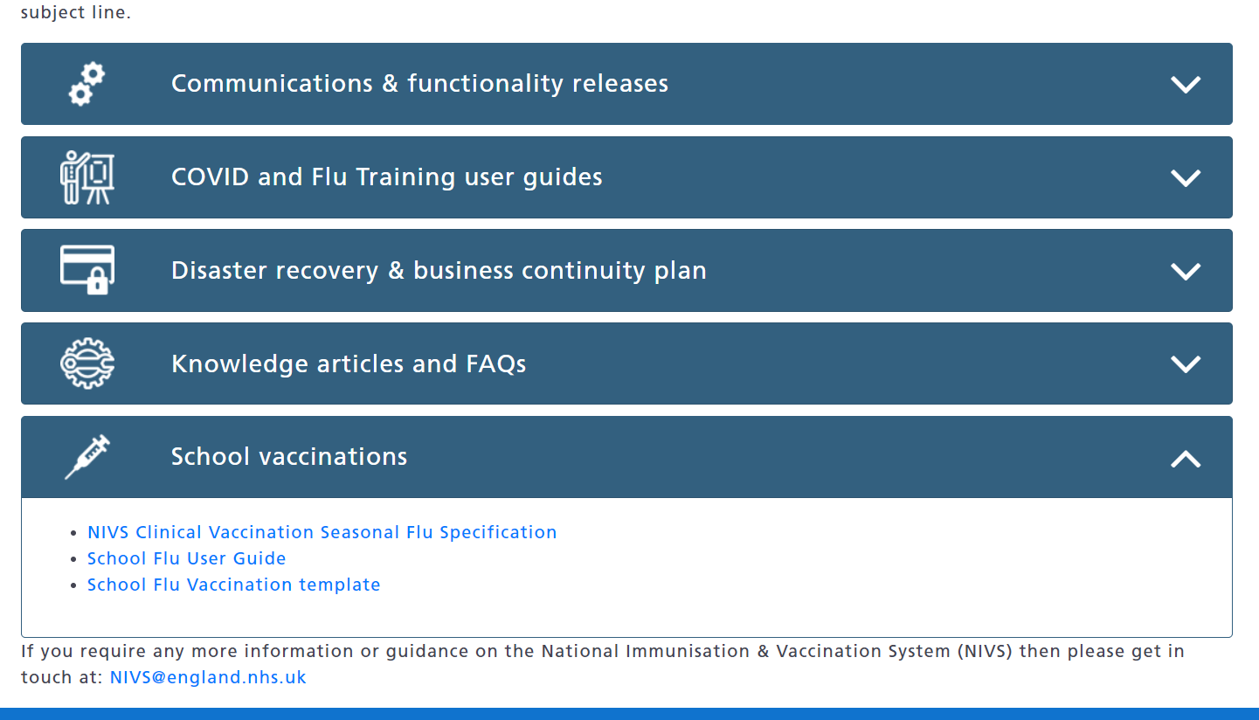

The template contains the necessary fields that are required to upload school flu vaccinations in NIVS.

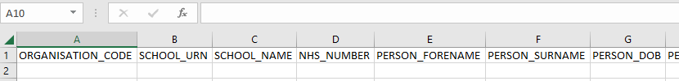

The specification contains the information with examples to help complete the template fields.

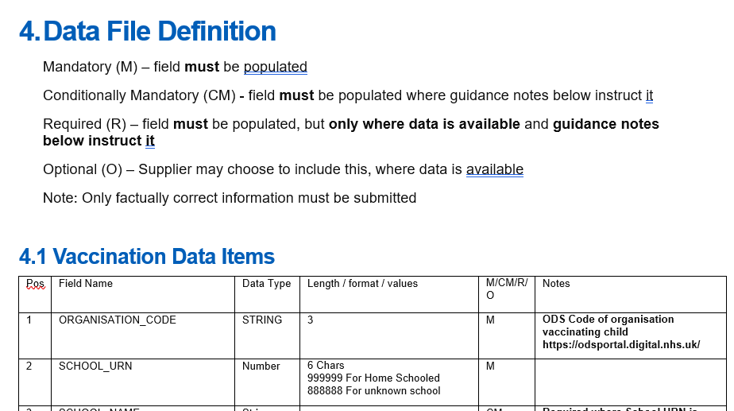

Scrolling down to the Data file definition you will find a list of all the fields found on the template and additional information about them.

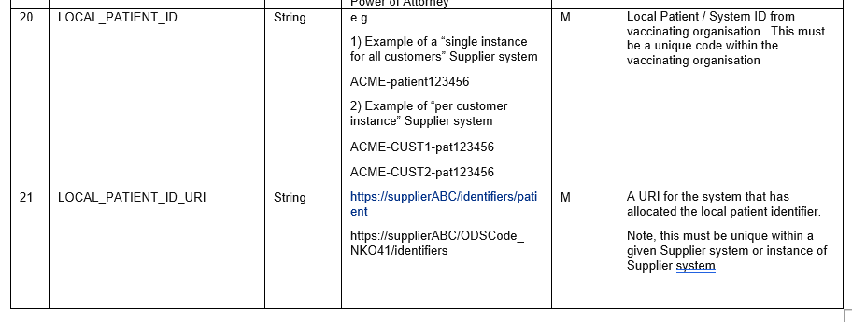

Entries for Field 20 Local patient ID must be the local patient/system ID from whatever supplier system your organisation uses, this ID must be unique to the patient and a unique code within your organisation. some examples of this ID are provided on the specification using Cinnamon as the example supplier system.

Entries for Field 21 local patient ID URI will be the URI that your supplier system has allocated the local patient ID used in field 20, this must be unique within the given supplier system or instance of the system. In situations where a supplier has multiple systems then the systems can be numbered 1,2,3 etc.

# Uploading School Flu Vaccination Files

Once you have filled in the CSV file, you will need to submit the CSV file using the upload function, following either of the 2 steps below:

1. Click on **Upload School Flu Vaccinations** under the **Schools** dropdown on the top banner.
2. Click on the **School Flu Vaccinations** box, and then click on **Upload School Flu Vaccinations** on the subsequent screen.

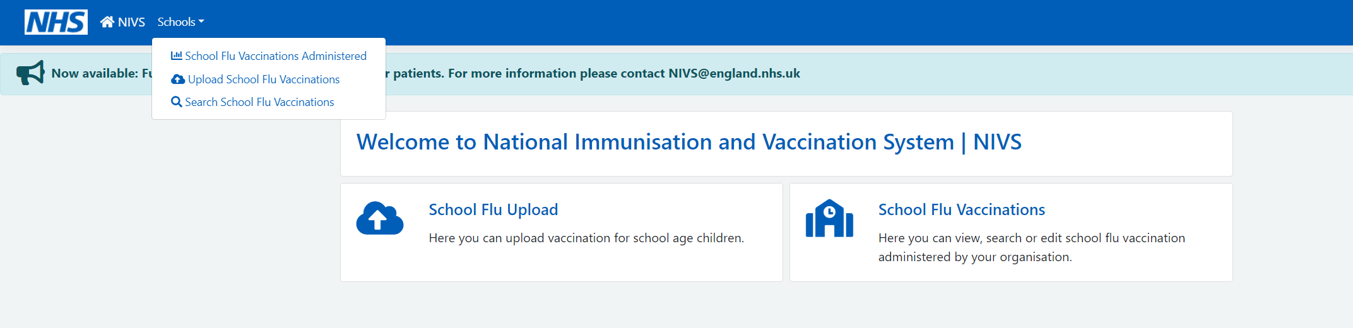

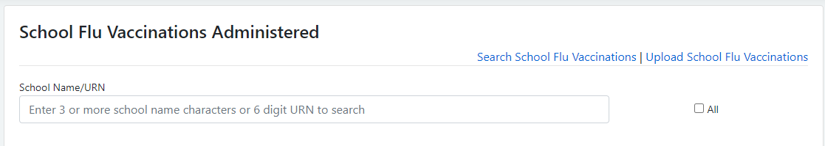

Following either of the steps above will take you to this screen below, where you can upload the vaccination file:

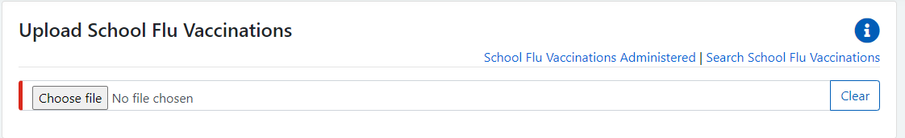

The system will validate your file, highlighting any identified errors. These will need to be corrected before you are able to upload.

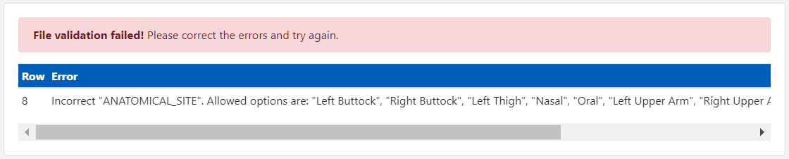You can see from the example above that, if there are any errors, it will highlight which row the error is on and the field that needs attention.

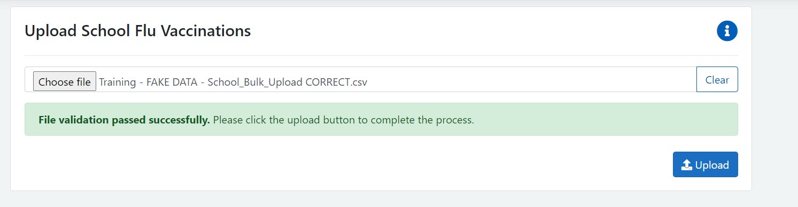Once this has been corrected you will get a message, saying the file has passed validation, as per below. REMEMBER to press the Upload button.

# Editing School Flu Vaccination Records

To edit a school record that has been uploaded incorrectly, you will need to click on this option on the homepage:

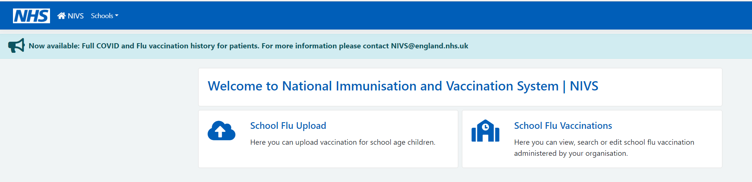

Once you have clicked on this, you will need to click on Search School Flu Vaccinations, as below:



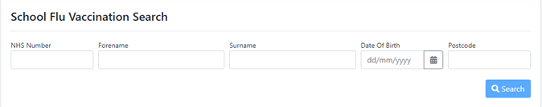You will be directed to this page, where you will be able to search for the record that needs editing by entering the demographic details and selecting search.

NOTE: You can search using partial demographic data.

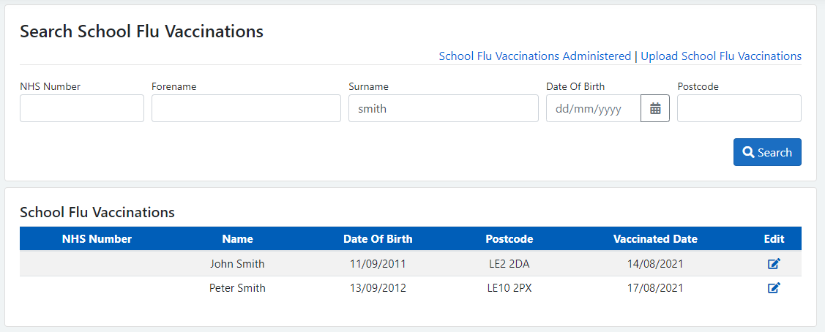Once you found the record that you want to edit, select the correct version, and edit by selecting the last blue box at the end of the record.

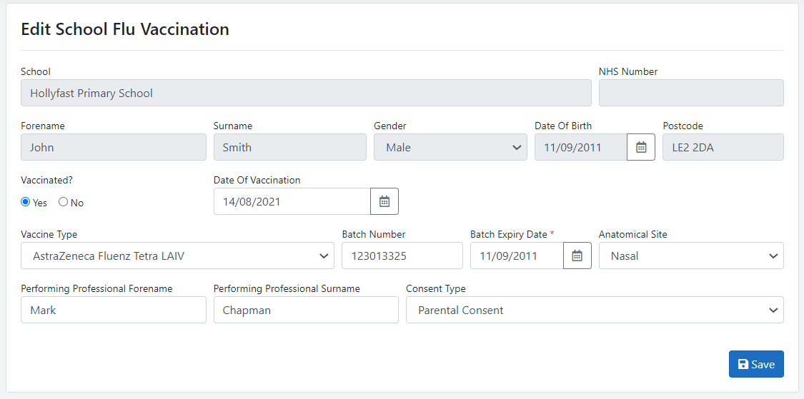You are then able to edit the record you want and change the details that have been entered by mistake. Once you have finished, select Save.

Note: Privately administered vaccination are NOT shared with NHS England therefore will not be shown on NIVS.

# School Flu Vaccination details for your Organisation

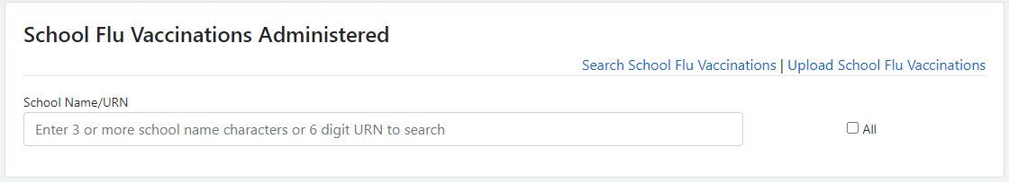On the home page for school age vaccinator, there is now the option to see the total School flu vaccinations for your organisation.

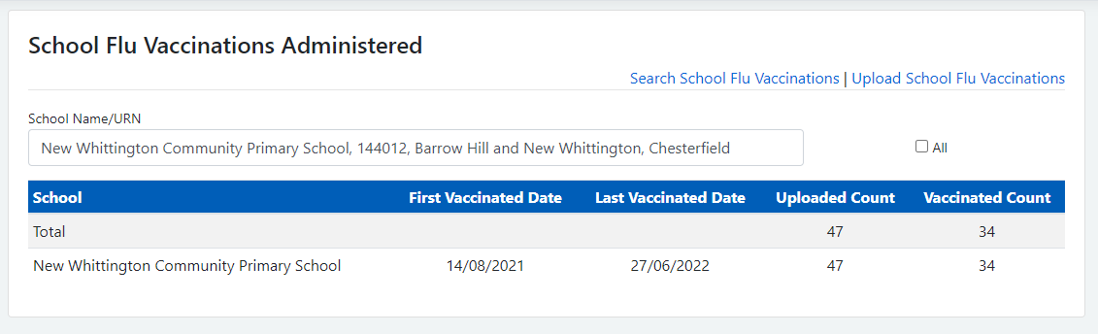You can search for the school’s name or URN number. This will then bring you back the details of the first and last vaccination dates and the total count.

# Contact Details

For most queries, you should email the helpdesk with any screenshots or descriptions of any issues you are experiencing. We are also contactable by phone.

**Email:** [nivs@england.nhs.uk](mailto:nivs@england.nhs.uk)

**Phone:** 0121 611 0187

**Helpdesk Operating Hours:** Monday to Friday: 08:00 – 18:00, Saturday and Sunday: 08:00 - 16:00

You can also find further supporting documentation on the Arden & GEM website: <https://www.ardengemcsu.nhs.uk/nivs>

|  |  |  |  |  |
| --- | --- | --- | --- | --- |
| Version | Date | Author | Approved By | Description |
| 1.0 | 12/08/2022 | Harrison Whitworth | Vicky Nelson | Initial Version |
| 1.1 | 28/07/2023 | Jack Waters | Vicky Nelson | Updated Version |
|  |  |  |  |  |